**PUNCTUATION MARKS**

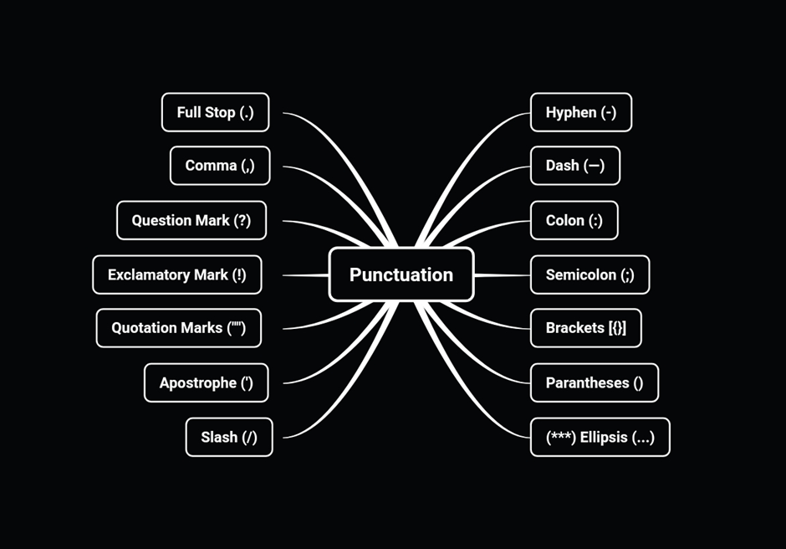

**Full Stop (.)**

A [**full stop**](https://7esl.com/full-stop/), also known as a period ([**.**](https://7esl.com/full-stop/)) in American English, is one of the most commonly used punctuation marks in the English language. Analysis of texts indicates that approximately half of all punctuation marks used are full stops.

The punctuation rules:

* Mostly used at the end of a declarative sentence, or a statement that is considered to be complete.
* This punctuation mark is also used following an [**abbreviation**](https://7esl.com/texting-abbreviations/).
* A full stop can also show the end of a group of words that don’t form a typical sentence.

The full stop examples:

* *My name’s Beth and I was 18 in July.*
* *Mr. White was talking with Mr. Smith.*

**Question Mark (?)**

We use a [**question mark**](https://7esl.com/question-mark/) ([**?**](https://7esl.com/question-mark/)) after an interrogative sentence in English.

Examples:

* *“Have you a pen I can borrow?” she asked.*
* *Where are you from?*

**Quotation Marks/Speech Marks (” “)**

We use [**quotation marks**](https://7esl.com/parentheses-brackets-quotation-marks-ellipsis/) ([” “](https://7esl.com/quotation-marks/)) for [direct](https://7esl.com/direct-indirect-speech-tense-changes/) quotations in English.

Examples:

* *“I feel I’ve really earned this, ” she said, taking up her mug of tea.*
* *” I told a fib about my age, ” little Tom said.*
* *“It is a historic moment,” he told journalists.*
* *“Fine, thanks,” he replied in a cheerful manner.*

**Apostrophe (‘)**

An [**apostrophe**](https://7esl.com/apostrophe/) ([**‘**](https://7esl.com/apostrophe/)) is used to show that certain letters have been omitted from a word. The punctuation symbol can also be used to show the possessive form of a noun, in addition to indicating the plural form of lowercase letters.

The apostrophe rules:

**(1) Use an apostrophe in contractions**

* *He is = He’s*
* *I am = I’m*
* *Do not = Don’t*
* *They have = They’ve*
* *It is = It’s*
* *I would = I’d*
* *Let us = Let’s*
* *She has = She’s*
* *Who is = Who’s*

**(2) Use an apostrophe to indicate possession**

The apostrophe examples:

* *He joined Charles’s army in 1642.*
* *Sally’s hair was blond and curly.*
* *We have put together an anthology of children’s poetry.*
* *The boy’s sister travelled by bus to meet us.*

**Comma (,)**

A [**comma**](https://7esl.com/comma/) ([**,**](https://7esl.com/comma/)) is used to show the difference between two separate ideas or elements within a sentence. Commas have other uses as well, as they can be used to separate numbers, and write dates.

The comma rules and examples:

**(1)**Add a comma when two separate sentences are combined

Example: *We purchased some cheese, and we purchased some fruit.*

**(2)**Use commas between words in a series. Notice that a comma does not follow the last word in the series

Example: *He was tall, dark, and handsome.*

**(3)**Use a comma to separate an introductory element from the rest of the sentence

Example: *As the day came to an end, the firefighters put out the last spark.*

**(4)**Use the comma to set off the words “yes” and “no”.

Example: *No, thank you.*

**(5)**Use a comma to set off a tag question from the rest of the sentence.

Example: *She is your sister, isn’t she?*

**(6)**Use a comma to indicate a direct address.

Example: *Is that you, Mary?*

**(7)** Add a comma when a participle phrase clause is used.

Example: *Walking slowly, I could see the beautiful flowers.*

**(8)** Use a comma to separate parts of the date.

Example: *Tuesday, May 2, 2016, was when I graduated.*

**Hyphen (-)**

A [**hyphen**](https://7esl.com/hyphen/) ([**–**](https://7esl.com/hyphen/)) is a punctuation mark with three main uses. Many people confuse this punctuation mark with the dash, but the two are quite different. The hyphen can be used in compound words, to link words to prefixes, and also as a way to show word breaks.

The hyphen rules and examples:

**(1)**Use a hyphen to join two or more words together into a compound term. Do not separate the words with spaces.

Examples:

* *My eight-year-old boy loves reading.*
* *I work part-time.*
* *Self-expression*
* *Self-confidence*
* *Self-consciousness*
* *Nineteenth-century history*
* *Old-furniture salesman*
* *Off-the-peg suits*
* *Self-paced learning exercises*

**(2)** To link prefixes to words.

For example: *These things happened before the pre-enlightenment era.*

**(3)** To indicate word breaks

For example: *Unlike what some people might think, the twentieth-century was very different from other preceding time periods.*

**Dash**

The [**dash**](https://7esl.com/em-dash-en-dash/) is used to separate words into statements.

There are two kinds of dashes, the en dash, and the em dash. The en dash shows range or connections. On the other hand, the em dash is used in places where a comma could also be used. The dash can also be used to mark off words or statements that are not important to the meaning of the statement. The dash can also be used in places where a comma would be typically used.

**En dash (–)**

Slightly wider than a hyphen, the **[en dash](https://7esl.com/em-dash-en-dash/)** is a symbol ([**–**](https://7esl.com/en-dash/)) that is used in writing or printing to indicate a range or connections.

Examples:

* *1880 –1945*
* *Princeton–New York trains*

**Em dash (—)**

Twice as long as the en dash, the **[em dash](https://7esl.com/em-dash-en-dash/)** ([**—**](https://7esl.com/em-dash/)) can be used in place of a comma, parenthesis, or colon to enhance readability or emphasize the conclusion of a sentence.

Example: *She gave him her answer—No!*

**Exclamation Mark (!)**

An [**exclamation mark**](https://7esl.com/exclamation-mark/) is used to show emphasis. It can be used in the middle of a sentence or at the end of a sentence. When used at the end of a sentence, it also takes on the role of a full stop or a period.

We often use an exclamation mark ([**!**](https://7esl.com/exclamation-mark/)) to show strong emotion or give a command.

Examples:

* *Stop!*
* *Yeah!*
* *Sit down!*
* *What a lovely view you have here!*
* *That’s fantastic!*
* *Johnny, don’t touch that!*
* *Help!*
* *Good heavens!*
* *Aaarrgh!*

**Colon (:)**

A [**colon**](https://7esl.com/semicolon-colon/) ([**:**](https://7esl.com/colon/)) is a fairly common punctuation mark with a varied number of uses. It can be used to introduce a quotation, an example, a series, or even an explanation. Secondly, it can be used to separate two independent clauses. Finally, a colon can be used to show emphasis.

Examples:

* *You have two choices: finish the work today or lose the contract.*
* *That’s because we have one goal: for you to consider your website a success.*
* *John has all the ingredients:*[*minced*](https://dictionary.cambridge.org/dictionary/english/minced)*clams, milk, potatoes, and onions.*

**Semicolon (;)**

A [**semicolon**](https://7esl.com/semicolon-colon/) ([**;**](https://7esl.com/semicolon/)) is used to separate two independent clauses while still demonstrating that a close relationship exists between them. The semicolon does a better job of showing the connection between two statements than a full stop would.

Examples:

* *My daughter is a teacher; my son is a doctor.*
* *There are eight members in the team: two from China, Japan; three from France, Spain; two from Brazil; and one from India.*
* *Richard always slept with the light on; he was afraid of the dark.*

**Parentheses ( )**

[**Parenthesis**](https://7esl.com/parentheses-brackets-quotation-marks-ellipsis/), ( [**()**](https://7esl.com/parentheses/) ) are quotation marks that show additional thoughts about a statement. In many scenarios, they can be replaced by commas without any changes to the meaning of the sentence.

We also often use parentheses to set off less important details.

Example: *The two brothers (Richard and Sean) were learning how to play guitar.*

**Brackets [ ]**

[**Brackets**](https://7esl.com/parentheses-brackets-quotation-marks-ellipsis/) are squared off quotations ([**[]**](https://7esl.com/brackets/)) that are used to show information of a technical nature. Even if this information is omitted entirely, the sentence would still make sense.

For example: *Was he [the defendant] there when you arrived?*

**Ellipsis (…)**

An [**ellipsis**](https://7esl.com/parentheses-brackets-quotation-marks-ellipsis/) is usually represented by three dots ([**…**](https://7esl.com/ellipsis/)), although it can also be represented by three asterisks (***). This punctuation symbol is used to show that there has been an omission of some letters or words. In many cases, ellipses are used to cut statement short to avoid unnecessary or irrelevant words that have no impact on the meaning of the statement being made.

We often use an ellipsis to show that parts of sentences are left out.

Examples:

* *To be continued…*
* *You’ll never believe what I saw…*

**Slash (/)**

A [**slash**](https://7esl.com/slash/), which is also known as a forward slash, a virgule, or even an oblique dash, has a number of uses. The slash can be used to separate lines in a song or poem when they are written in a continuous line. The slash ([**/**](https://7esl.com/slash/)) is also used in place of the word or. The slash can also be used to show two contradictory notions.

The slash punctuation rules and examples:

**(1)** Use slashes to separate parts of the internet (web) addresses and file names for some computer programs.

Example: *http://www.example.com/*

**(2)** Use slashes for fractions

Example: *1/3 = one-third*

**(3)** Use a slash to separate the day, month, and year in date.

Examples:

* *w/o = without*
* *n/a or N/A = not applicable or not available*
* *R/C = radio control*

**(4)** Use a slash to show the word “per” in measurements.

Example: *80 miles/hour = 80 miles per hour*

**(5)** Use a slash to separate lines of poetry or rhymes in regular text.

Example: *Twinkle, twinkle, little star, / How I wonder what you are. / Up above the world so high, / Like a diamond in the sky.*

**(6)** Use a slash to show alternatives in a sentence.

Example: *Please press your browser’s Refresh/Reload button.*

